COMMERCIAL METEOROLOGY – PRE TEST

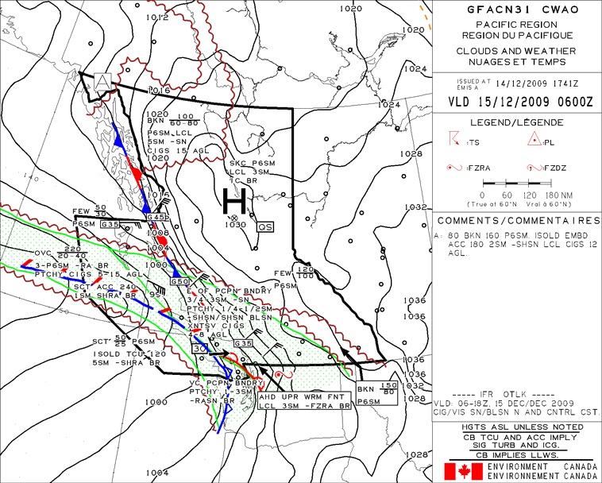

Questions:
- The area of high pressure in the central and northern interior is moving at what speed over the surface?
- Off the Northwest coast of Vancouver Island, the surface winds are forecast to be from what direction and of what intensity?
- When the cold front that is sweeping across Vancouver Island passes through, the surface winds can be expected to veer/back (choose correct answer).
- What is causing the area of extensive continuous precipitation?
- The IFR outlook found in the bottom of the comments box is found only on which set of the clouds and weather chart?

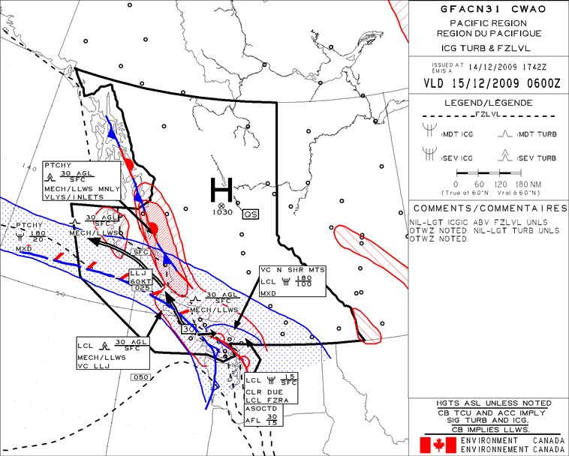

- The severe icing forecast in the vicinity of the north shore mainland mountains is due to what weather occurrence?
- The forecast for severe turbulence over the central coast near the Queen Charlotte Islands implies what in terms of aircraft control, should you encounter it?
- If you were to fly from the interior of the province towards and through the warm front lying over the southern straight of Georgia, you could expect to first see solid precipitation, followed by what in terms of precipitation order as you fly towards and through the front?
- Clear icing is more often caused by what sized water droplets?
- Is light icing forecast on this chart?

